AI ASSISTED CODING
Task Description#1
- Use Copilot to generate a is_prime() python function.

Expected Output#1
- Correct examples verify it True or False

Question
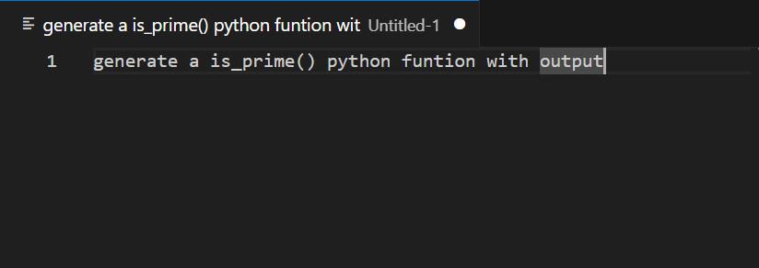

Code
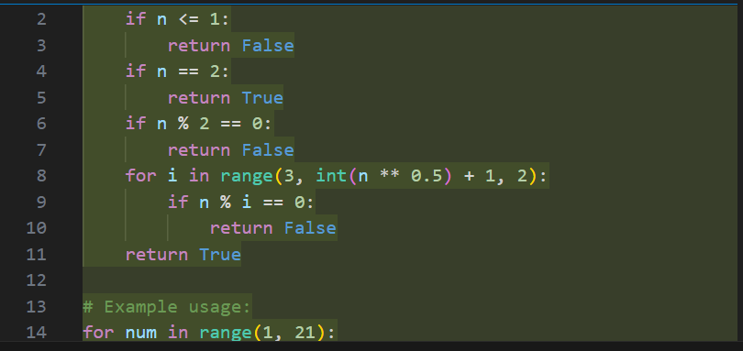
Output
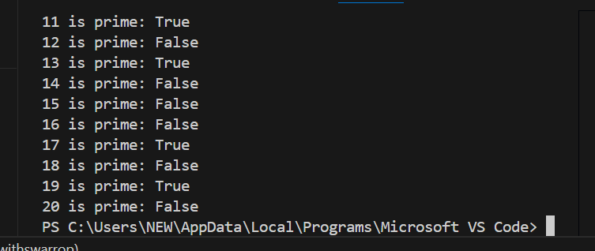

Task Description#2
- Generate a python program for Reverse of a string by using copilot.
Expected Output#2
- Verify the correct output by giving the reverse string as input

Question
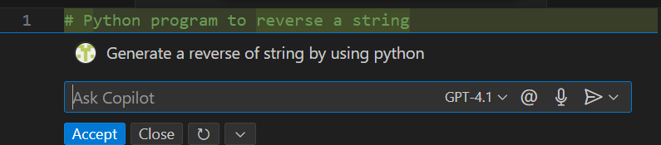

Code
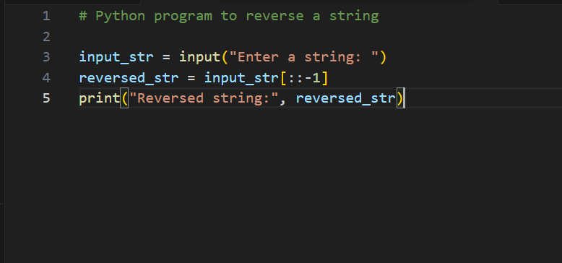

Output
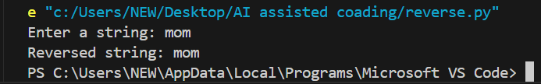

Task Discription#3
- Generate a python program for Recursive and Iterate using with python function.

Expected Output#3
- Verify the expected output of the program.

Question
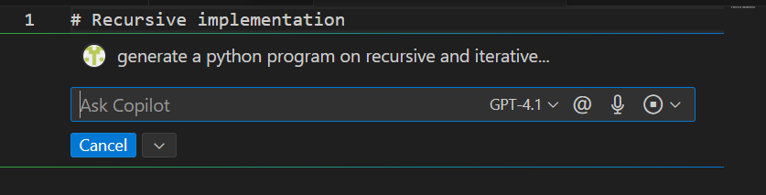

Code
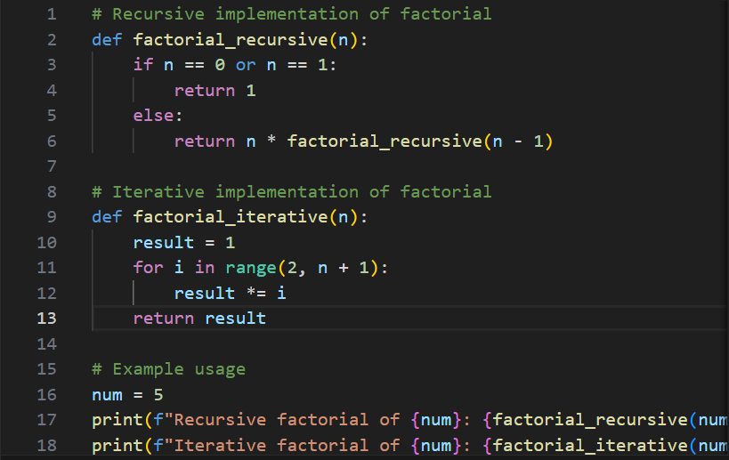

Output
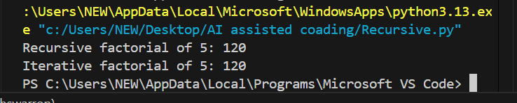

Task Discription#4
- Generate the python program for finding the Largest number and assiss by the copilot.

Expected Output#4
- Verify the expected output and review of the code.

Question
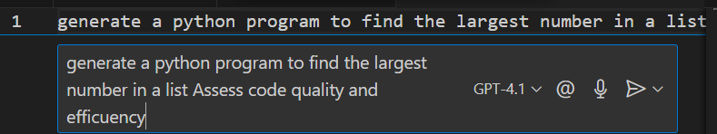
Generated Code
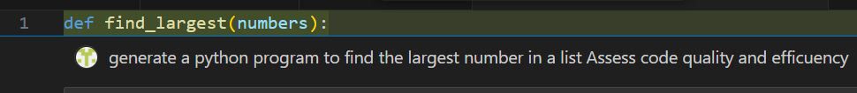
Code
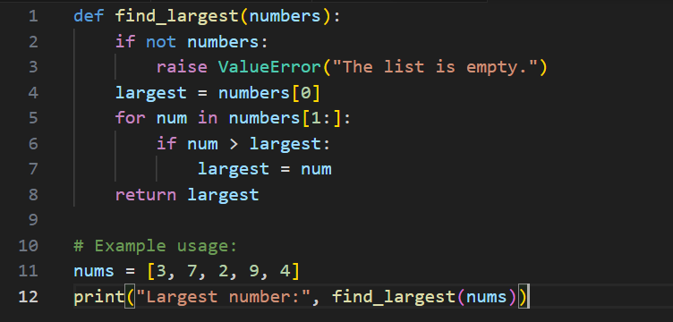
Output
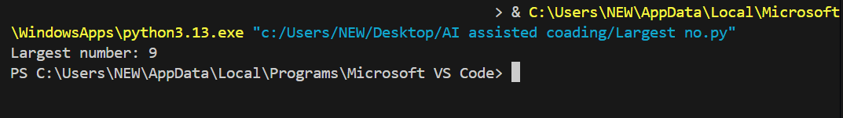

-------------------------------THE END--------------------------------------

